System Design Document
Consolidated Disease Demographics
Reporting System

CMSI 641 Software Engineering
Fall 2002
Jeff P. Lankford, Instructor

Team 2 Document by
Craig E. Ward
Harshitha Elango

1 Introduction 4
2 System Architecture 6
2.1 Component Diagram 6
2.2 Component Descriptions 6
2.2.1 Internet 6
2.2.2 HL7 Filter 7
2.2.3 Native XML Filter 7
2.2.4 RDBMS 7
2.2.5 Consolidation Engine 7
2.2.6 Interactive User Engine 8
2.2.7 Query Subsystem & Data Extracts 8
3 Software Specification 9
3.1 Operational Design 9
3.2 Uses Cases 9
3.2.1 Load Data 10
3.2.2 Extract Data 10
3.2.3 Query Data 10
3.2.4 Fix Message Errors 10
3.2.5 Archive Data 11
3.3 Classes 11
3.3.1 Data Model Classes 12
3.3.2 Controller Classes 14
3.3.3 View Classes 15
3.4 Sequence Diagrams 16
3.4.1 XML Message Input 16
3.4.2 HL7 Message Input 16
3.4.3 Error Message Processing 17
3.4.4 Data Query 17
3.4.5 Consolidation 18
3.4.6 Error Correction 18
3.5 Deployment Diagrams 18
3.5.1 Deployment for Message Processing 19
3.5.2 Deployment for Query Processing 20
3.6 Class Implementation Patterns 20
4 Database Design 22
4.1 Entity Relationships 22
4.1.1 Formal Relationships of Primary Data Objects 22
4.1.2 Formal Relationships of System Data Objects 23
4.2 Table Layouts 24
5 Software Development Environment Specification 26
5.1 Hardware 26
5.2 Software 26
5.2.1 Operating System 26
5.2.2 Programming Tools 26
5.2.3 Office Software 26
5.2.4 Database Engine 26
6 COTS Software Specification 27
6.1 Development Licenses 27
6.2 Production Licenses 27
6.3 Additional Third-Party Software 27
7 Validation and Verification Plan 28
7.1 Testing Process 28
7.2 Requirement Traceability 28
7.3 Tested Items 29
7.4 Test Recording Procedures 29

Introduction

The Consolidated Disease Demographics Report System (CDDRS) is a data warehouse of the demographics related to diseases. The system is run under the auspices of the World Health Organization.

CDDRS is capable of supporting research and statistical analysis on a world-wide basis. Hospitals, government agencies, and health organizations are able to submit data in standard formats for incorporation into the database. Researchers, health professionals, and government officials will be able to query the system for data to aid in analysis in these areas:

- Trends of diseases over time;
- Trends of disease progression over geographic areas;
- Development of new occurrences of disease outbreaks;
- Combinations of the above.

Some queries can be made interactively. Other queries can be used to generate data extracts for further analysis by the requestor’s own systems.

The Internet is the main conduit for data to be incorporated into the CDDRS database and one of the primary means of making queries to the system. A batch method of entering data is also available.

The following picture illustrates the basic architecture.

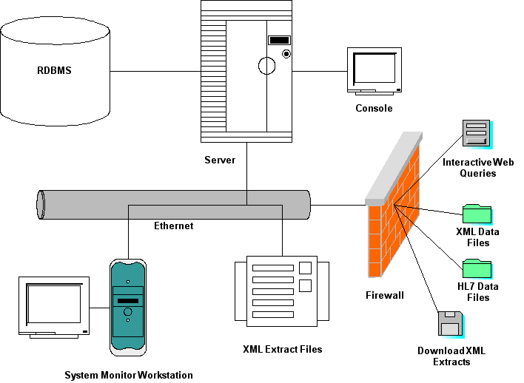

System Components Illustration

System Architecture

Component Diagram

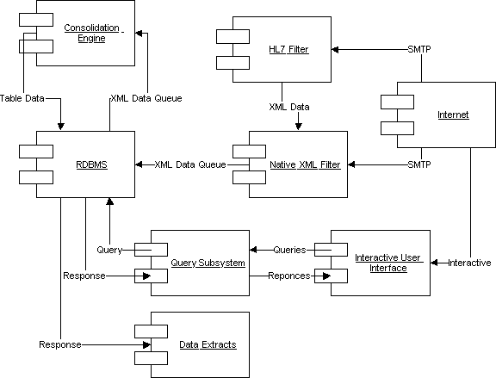

System Component Diagram

Component Descriptions

Internet

The internet is used for transferring of data and Simple Mail Transfer Protocol (SMTP) is used for receiving the data.

The exchange of mail using TCP/IP is performed by a message transfer agent (MTA). Users normally don’t deal with the MTA. The system administrator is responsible to set up the local MTA. The SMTP protocol describes how two MTAs communicate with each other using a single TCP connection.

SMTP uses the concept of spooling. The idea of spooling is to allow mail to be sent from a local application to the SMTP application, which stores the mail in some device or memory. Once the mail has arrived at the spool, it has been queued. A server checks to see if any messages are available and then attempts to deliver them. Eventually, if the mail cannot be delivered, it will be discarded or perhaps returned to the sender. This is known as an end-to-end delivery system, because the server is attempting to contact the destination to deliver, and it will keep the mail in the spool for a period of time until it has been delivered.

The data is received in two formats either as a HL7 format or in a XML format through the SMTP.

HL7 Filter

HL7 is an international standard for defining medial and health related data for exchange between systems.

The HL7 Filter takes the formatted data received through email and transforms it into the CDDRS native XML format.

Native XML Filter

The XML Filter has two major roles the input which is obtained is stored in the form of a queue, the data is from both the HL7 filter and native XML the data obtained are processed by consolidation engine. The other important feature of the XML filter is that data which is obtained and the querying are done in the xml filter and insertion of files are also done here.

RDBMS

The relational database management system is where the data is stored and retrieved . The query subsystem which is present is linked to the RDBMS to query and get the results back; it is also linked with the consolidation engine where the XML data queue is linked and the data table is retrieved back from the engine. The data which is requested and the response is got by the data extract.

Consolidation Engine

The files which are being read by the XML filter and the HL7 filter is indeed processed by the consolidation engine and the data it sent to the XML data queue from RDBMS and the response which is received is the data table.

Interactive User Engine

The user engine is used as interface between user and the rest of the system the queries are sent to the query sub system and it is sent response is sent back. Data which is extracted is put inside the data file and it is assessed.

Query Subsystem & Data Extracts

The system is used to query for the data and get the data, the response from the RDBMS. The data extract will have a firewall to check for the authorized user to query data, Using as File server and ftp to download or email.

Software Specification

Operational Design

The design explains the operations which are being carried out in the database internally the USER has a real name with which the user will be recognized and to log in to system with a user name and the user id which is given to the user only through which the user is being identified by the system.

The ROLE of the user can be obtained by knowing the privileges they have and they are allowed to accesses those items.

The QUEUE is present in the system to set the priority of the data which is being queried by the system, when the request is made to the system the date is being generated and so the query which is being processed by the date and there can also be set to a state which is urgent when the query is processed immediately.

Uses Cases

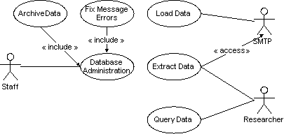

CDDRS Use Cases

The data is being loaded into the database using the SMTP either in the native xml or html format and the data is queried by the end user who is the researcher get the information he needs by querying the database and the data is extracted from the database and the result is sent back to the end user.

The staff is the one who takes care of the database system and when the error message occurs the error extends to the database administrator to fix the problem which has occurred.

Load Data
Use Case Name | Load Data
Assumptions | None
Pre-conditions | None
Initiation Trigger | Use case is triggered on demand
Main Flow of Events | - Incoming mail is delivered to the receiving process  - The receiving process stores the message in the input queue  - The consolidation process reads the message from the queue  - The consolidation process parses the data and creates the objects to insert the data  - The message is removed from the queue
Exceptions Flow of Events | - An error during the parse occurs  - The message and error text are stored in the error queue.
Post-conditions | None

Extract Data
Use Case Name | Extract Data
Assumptions | None
Pre-conditions | None
Initiation Trigger | Use case is triggered on demand
Main Flow of Events | - SQL query submitted to database  - Results captured and written to a file as XML  - XML file is mailed to requestor
Exceptions Flow of Events | - Error in the SQL code  - Error text sent to the requestor
Post-conditions | None

Query Data
Use Case Name | Query Data
Assumptions | None
Pre-conditions | None
Initiation Trigger | Use case is triggered on demand
Main Flow of Events | - SQL query submitted to database  - Results captured and sent back to requestor
Exceptions Flow of Events | - Error in the SQL code  - Error text sent to the requestor
Post-conditions | None

Fix Message Errors
Use Case Name | Fix Message Errors
Assumptions | User is administrative
Pre-conditions | None
Initiation Trigger | Use case is triggered on demand
Main Flow of Events | - Message with error is retrieved from queue  - If possible, data is corrected  - If not possible, message is deleted from queue
Exceptions Flow of Events | None
Post-conditions | None

Archive Data
Use Case Name | Archive Data
Assumptions | User is administrative
Pre-conditions | None
Initiation Trigger | Use case is triggered on demand
Main Flow of Events | - Process to remove old data initiated
Exceptions Flow of Events | None
Post-conditions | None

Classes

Data Model Classes

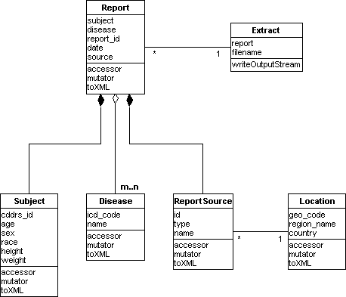

Data Model Classes

The model represents the way every query is being processed and the report is obtained the disease class and report will have many to many relationships and the location which gives the details about the diseases are where it is being located in the geographic location and the data is being extracted from the database which is present .

Data Model Class Explanations

Subject

The class which is present in the database has disease code id, the age and the sex of the particular patient and then the access the files from the XML native files.

Disease

The diseases code gives the information about the disease and the diseases code which is obtained from the database, the disease name and which in turn is liked to the XML native files where the data is obtained from and the only class which has a many to many relationship is the disease class and it is connected to the report class.

Report Source

The report which has the object such as the id, type, name and it is and this is connected to the location class which are inter liked to each other and the relation is one to one relationship .

Location

The location code that is where the information which is queried upon is obtained from the region code and the country in which the diseases where of the particular type is located from.

Extract

This is the class from where the data is being retrieved from the report and the filename is obtained from this class and it is linked to the output stream where the output is written to the report file.

Controller Classes

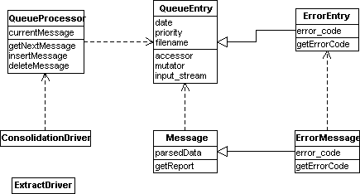

Controller Classes

Controller Class Explanations

Consolidation Driver

The Consolidation Driver is asynchronously instantiated to control the extraction of messages from the input queue and process the data for incorporation into the database.

Extract Driver

The Extract Driver runs asynchronously to process the requests for data that will be written to the file system for later pickup by the researcher user.

Queue Processor

The Classes which are mainly present in the database to control the query is that it has it database has a internal consolidation driver which gets all the query from the user and the Queue Processor which is present gets the current message from the user and all the operations which are to be done are performed in this class the message which is obtained are inserted and deleted into the file using this class.

Queue Entry

This is the central part which is present in the database among all the classes; the entry queue is further linked with the error controller and the message reporter in the system which is present. The class in turn has the following object and the operations which are being carried out are date in which the query is being processed and the priority level it has been set. The input stream is also present and the accessor also present.

Error Entry

The error code is generated which the error is being encountered by the system and the error message class is being invoked when this takes place.

Message

The data which is being parsed is processed and the query is run and when report is being generated when there is a error which is encountered the error message class is

Archive Controller
The Archive Controller is asynchronously instantiated to remove old data from the database. The administrative policies governing the use of this feature have not yet been determined.

View Classes

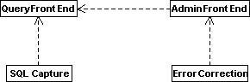

Query Front End

The Query Front End manages the interface elements of user interaction. Depending on the user, the QFE presents a SQL capture screen or one of the administrative screen, e.g. the Error Correction screen.

Sequence Diagrams

The diagrams in this section illustrate the main processing paths for data input, error processing, error correction, and query processing.

XML Message Input

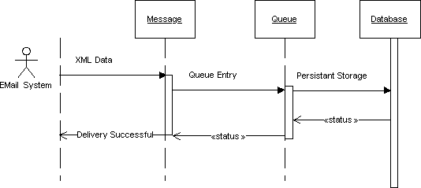
Input from message using CDDRS XML format

HL7 Message Input

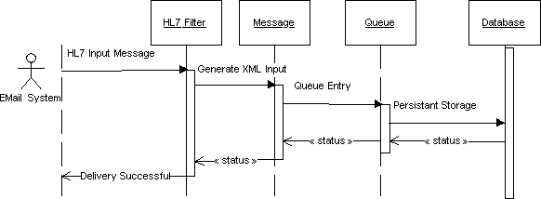
Input from message using HL7 data format

Error Message Processing

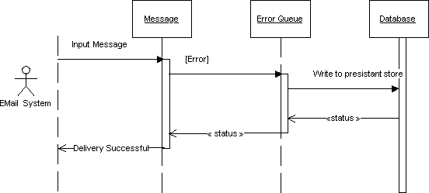
Processing of messages with errors

Data Query

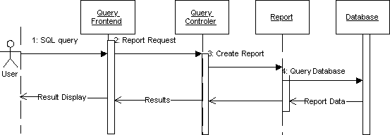
SQL query processing

Consolidation

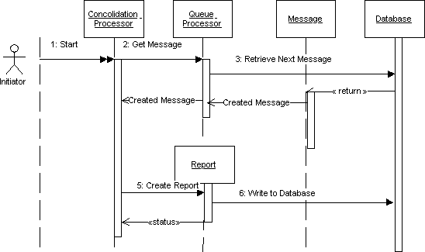

Message consolidation into the database

Error Correction

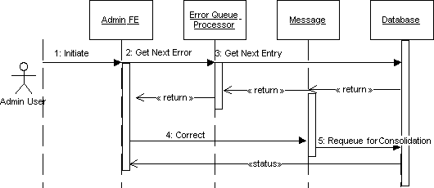

Administrative error processing

Deployment Diagrams

The following diagrams illustrate the planned deployment of components.

Deployment for Message Processing

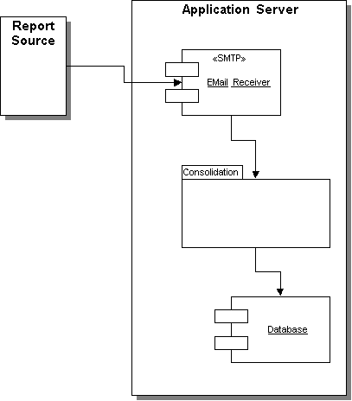

Deployment for Query Processing

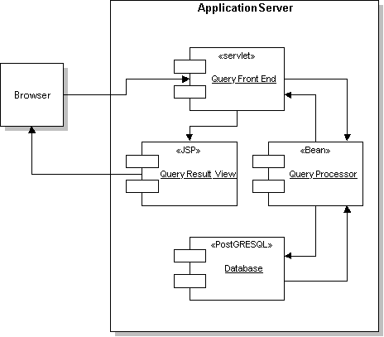

Class Implementation Patterns

The object entities of the system are to be implemented using a data-access-object/bean-object/data-model-object paradigm. That is, access to the database is to be separated from the object implementation and the data, after it is extracted, is to be available in a read-only state to user interface objects. This allows for greater flexibility in implementations and makes data integrity easier to maintain.

Additionally, the data model objects are to implement the “toXML” interface.

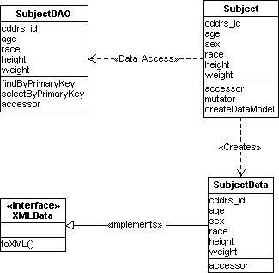

Implementation pattern for CDDRS objects

Database Design

Entity Relationships

This Simplified Entity Relationship Diagram represents the way the primary data objects of the system relate. A more formal diagram follows.

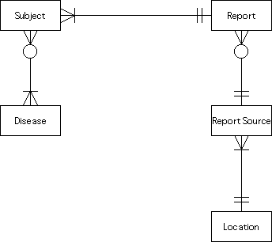

Simplified Entity Relationships

The disease code is linked to the subject which gets the processed information from the data base system after getting the query and the report is in turn is sent to the users where the location of the patient is located and further all the details about the particular query is obtained and the source report is sent back to the end user.

Formal Relationships of Primary Data Objects
This diagram shows the relationships and attributes of the primary data objects.

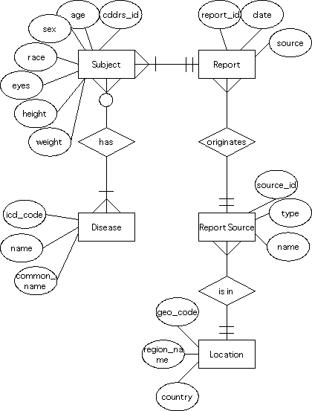
Entity Relationships with Attributes

Formal Relationships of System Data Objects

This diagram illustrates the system-related tables.
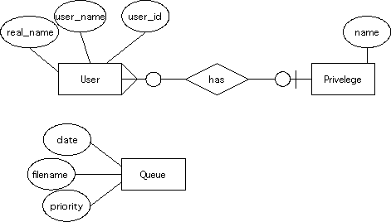

Attributes and Relationships of System Entities

Table Layouts

This data base design gives the explanation about the object which is present in the database

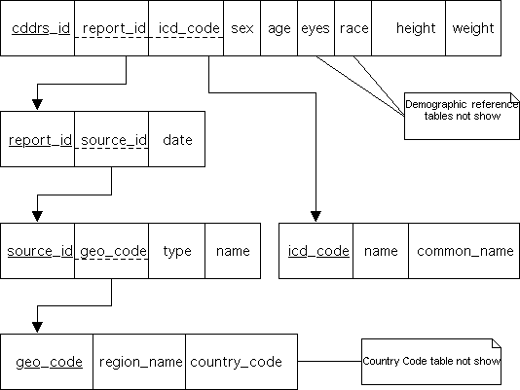

Logical layout of the database tables

The DISEASES table gives the details about the diagnosed disease with the name of the diseases (biological name/medical name) the disease id code which is also known as the ICD code and the also the common name which is been used for that particular disease

The SUBJECT gives the details about the person as a entity the details which are obtained from this are the persons id, age, sex, race, eye color, height and the weight of the person

The REPORT is being generated by the information which is obtained and the SOURCE , the database which is already existing which gives the detailed report along with the date on which it is being generated,

The REPORT SOURCE is where the details are obtained from it gives the details like source identification ,the type and the name of the particular information which is being queried , the report source is further linked with the LOCATION table which gives the information about the geographic code ,the region and the country where the particular information is got from.

Software Development Environment Specification

Hardware

Each software engineer, programmer, tester will need a workstation capable of running an IDE as well as word processing and other office software. The project manager will need a machine capable of running any management tools.

To keep costs down, the project will use commodity hardware and open source system software and tools. Software requirements are listed in the next section.

Software

The programming language for CDDRS is Java 2™. The tools described here allow for the effective use of the language for the development of the software.

Operating System

The Linux operating system from Red Hat will be used on all development, server, and testing machines.

Programming Tools

CDDRS will use the Java 2™ Standard Edition and Java 2™ Enterprise Edition definitions from Sun Microsystems. Sun provides a supported implementation for Red Hat Linux.

Programming staff may use whatever IDE seems best suited to their own work styles and habits. What will be required of the IDE is that is work acceptably well with the source code control system, CVS.

Office Software

The Star Office suite of programs from Sun Microsystems will be used for word processing and spreadsheet needs.

Database Engine

The implementation of the back-end database will be Oracle 9i. The Oracle product is well respected and considered one of the best implementations of SQL available. Additionally, the Oracle system comes with the needed Java 2™ Enterprise Edition application server.

COTS Software Specification

Development Licenses

The project will require licenses at cost for these products:

Product | Explanation
Red Hat Linux (10) | System software
JBuilder (1) | Java IDE for developing GUI interfaces

Production Licenses

Product | Explanation
Red Hat Linux (2) | System software
Oracle 9i | Database engine

Additional Third-Party Software
Product | Explanation
HL7 Converter | Map HL7 data messages to CDDRS native XML

Validation and Verification Plan

Testing Process

The software inspection analyzes and checks system representation such as the requirement documents, design diagrams and program code. Software testing involves executing an implementation of the software with test data and examining the outputs of the software and its operational behavior to check that its performance as required.

The program inspection includes automated source code analysis and formal verification.
The software function, the level of confidence is dependent on how critical the software is.

The testing, which is carried out, is the defect testing is intended to find inconsistencies between program and its specification and the statistical testing is used to test the program’s performance and reliability and to check how it works under operational conditions. Test is designed to reflect the actual user inputs and their frequency. After running the tests an estimate of the operational reliability of the system can be made by counting the number of observed system failures. The program performance may be judged by measurement the execution time and the response time of the system as it processes the statistical test data.

Requirement Traceability

The requirements of the system are those, which are illustrated in system component diagram, and the verification, which is to be done, is to check whether the message, which is sent via the SMPT, is received in correct format as specified earlier the data can be transformed in two formats the native XML format or the HL7 format in the verification stage the data which is received is checked and to see if they are received in the same format which was sent.

The Query subsystem, which is used to retrieve the data from the database (RDBMS) in this stage of verification the query is being passed and to the query sub system and the it is checked to see if the data which is was requested is obtained and in the same format that it was requested for.

The Consolidation engine is checked to see if the table of data that is being sent is being received in the order in which it was sent and the order in which it is being processed the data which is received by the consolidated engine is being queued.

Tested Items

The data or the constraints which is has been tested should be documented so that it is not tested over and over again.

The different cases that should be tested should be when the data is being loaded the data that is loaded should be checked to see if it in the correct format the data which is sent can be only in two formats as mentioned.

The data which is to be extracted from database by processing request by the user is checked to see if the data which is got back after processing the query is the same format which was requested by the user. The time is also calculated that is the time when the query is sent and the time when the result is obtained back.

Test Recording Procedures

The data and the constraints which are checked should be stored or documented systematically so that it is used for the other person in the team to refer to it .

